19CSE313 Principles of Programming Languages

Lab Evaluation 3

29 April 2022

1. Write a concurrent program that accepts numbers from the user and prints a userdefined multiplication table in the same order. For example, the following shall be an example session.

Code:

import Control.Concurrent

import Control.Concurrent.STM

import Control.Monad

import Control.Monad.IO.Class

main :: IO ()

main = do

  putStrLn "Enter a number: "

  input <- getLine

  let num = read input :: Int

  putStrLn $ "Multiplication table of " ++ show num ++ ":"

  printTable num

printTable :: Int -> IO ()

printTable num = do

  let max = 10 :: Int

  let table = [1..max] :: [Int]

  let result = map (* num) table

  mapM_ print result

Output:

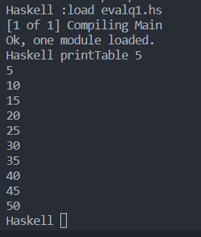

1. A program spawning two threads each printing respectively the characters ‘A’ and ‘B’ was discussed in the class. You saw that the resultant pattern is an interleaved pattern. Change the concurrent program so that you force all ‘A’s to be printed first followed by all ‘B’s.

Code:

Output: